

**SWS213LecCNET/NET320LecNET Database Systems**

**Spring 2018**

**Lab 1b**

**MySQL Workbench 6.3.10**

# Objectives

The objective of this lab is to install MySQL Workbench 6.3.10

# Background

**MySQL Workbench**

MySQL Workbench is a unified visual tool for database architects, developers, and DBAs. MySQL Workbench provides data modeling, SQL development, and comprehensive administration tools for server configuration, user administration, backup, and much more. MySQL Workbench is available on Windows, Linux and Mac OS X.

**Design**

MySQL Workbench enables a DBA, developer, or data architect to visually design, model, generate, and manage databases. It includes everything a data modeler needs for creating complex ER models, forward and reverse engineering, and also delivers key features for performing difficult change management and documentation tasks that normally require much time and effort.

**Develop**

MySQL Workbench delivers visual tools for creating, executing, and optimizing SQL queries. The SQL Editor provides color syntax highlighting, auto-complete, reuse of SQL snippets, and execution history of SQL. The Database Connections Panel enables developers to easily manage standard database connections, including MySQL Fabric. The Object Browser provides instant access to database schema and objects.

**Administer**

MySQL Workbench provides a visual console to easily administer MySQL environments and gain better visibility into databases. Developers and DBAs can use the visual tools for configuring servers, administering users, performing backup and recovery, inspecting audit data, and viewing database health.

**Visual Performance Dashboard**

MySQL Workbench provides a suite of tools to improve the performance of MySQL applications. DBAs can quickly view key performance indicators using the Performance Dashboard. Performance Reports provide easy identification and access to IO hotspots, high cost SQL statements, and more. Plus, with 1 click, developers can see where to optimize their query with the improved and easy to use Visual Explain Plan.

# Database Migration

# MySQL Workbench now provides a complete, easy to use solution for migrating Microsoft SQL Server, Microsoft Access, Sybase ASE, PostreSQL, and other RDBMS tables, objects and data to MySQL. Developers and DBAs can quickly and easily convert existing applications to run on MySQL both on Windows and other platforms. Migration also supports migrating from earlier versions of MySQL to the latest releases.

# Software Required

MySQL Workbench 6.3.10

# References

[*http://dev.mysql.com/downloads/tools/workbench/*](http://dev.mysql.com/downloads/tools/workbench/)

**Installing MySQL Workbench 6.3.10**

1. Navigate through [*http://dev.mysql.com/downloads/tools/workbench/*](http://dev.mysql.com/downloads/tools/workbench/)to download MySQL workbench.
2. Select Windows MSI installer and click on *‘Download’.*

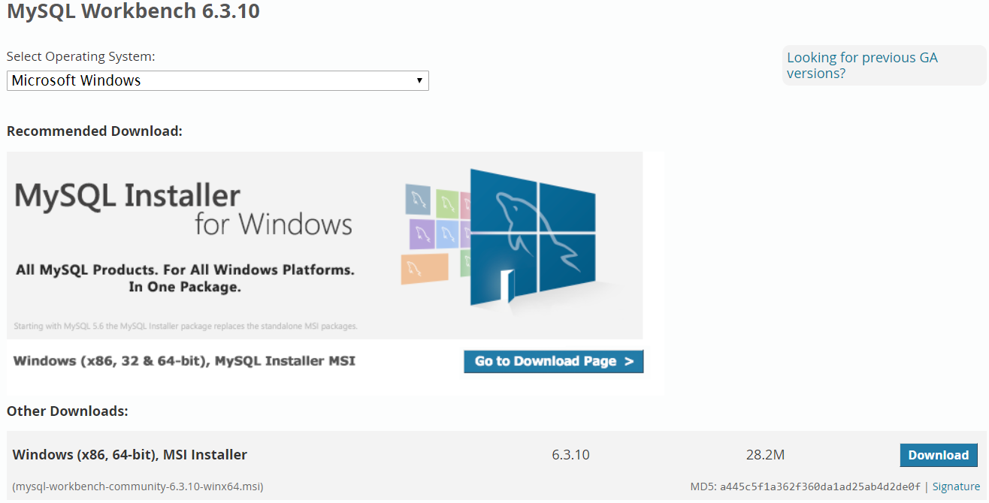

1. Select ‘*No thanks, just start my download*’.

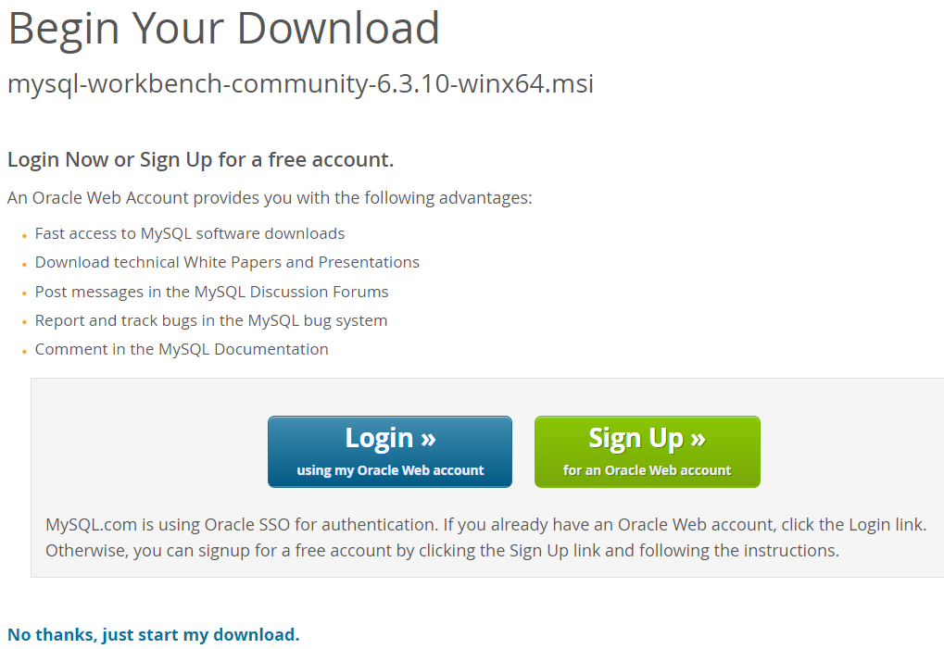

1. Save the file.
2. Run the file.
3. Click ‘Next’ on the Workbench installer.

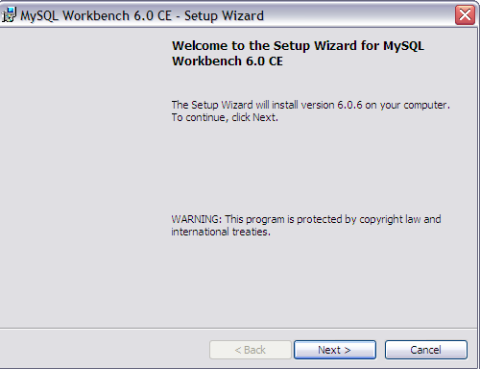

1. Select the destination folder and click on ‘Next’.

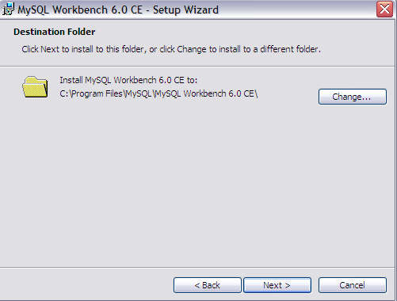

1. Select type as ‘Complete’ and click on ‘Next’.

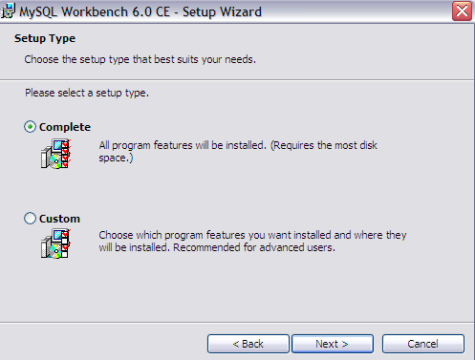

1. Workbench is ready for installation and click on ‘Next’.

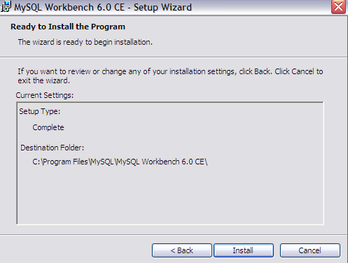

1. The installation will take a few minutes based on your computer.

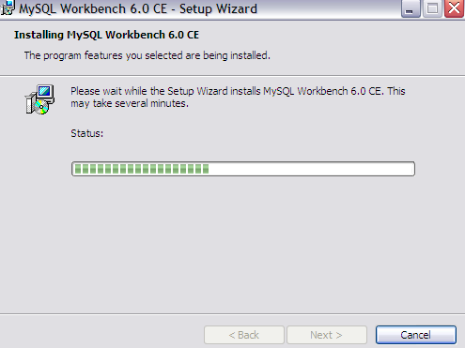

1. To complete the installation click on ‘Finish’.

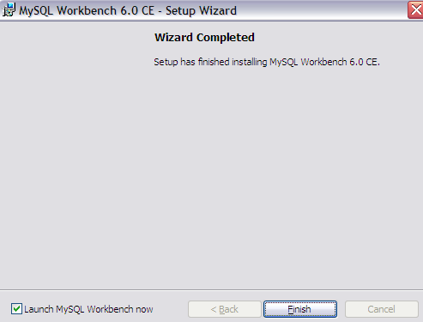

**To Launch Workbench from Start menu**

1. Click on Start, Programs, MySQL, MySQL WorkBench 6.0

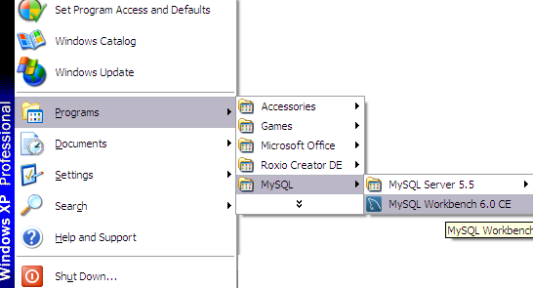

1. Now you are on the Workbench.

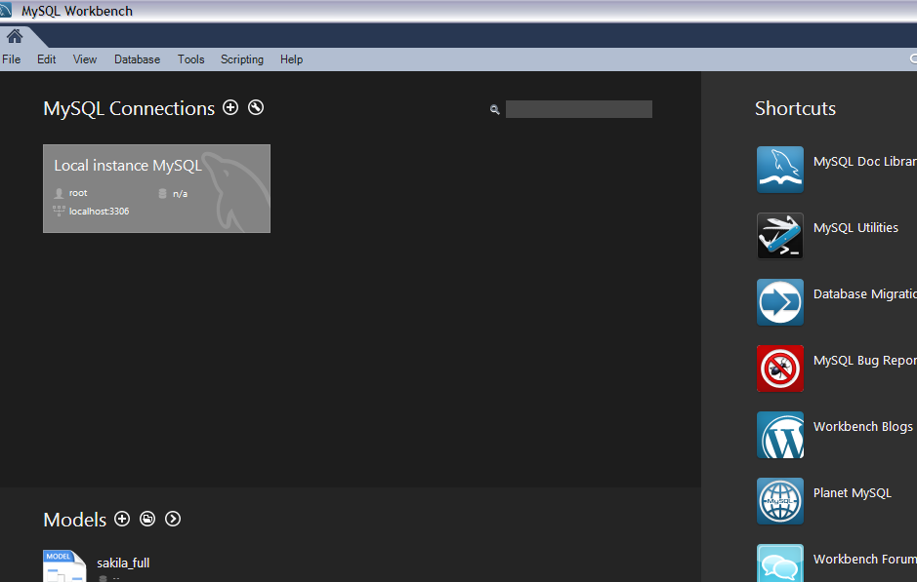

1. Double click on ‘Local instance MySQL’ and enter the password as ‘password’.

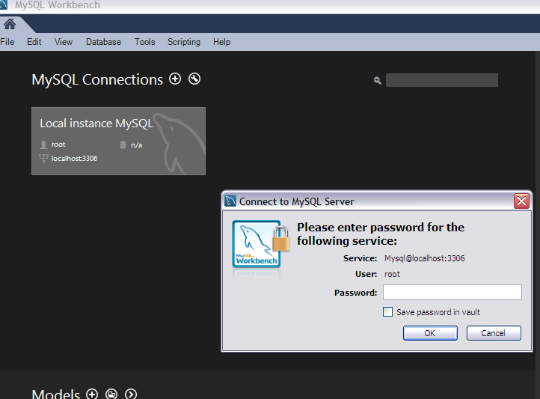

1. Now you are in the workbench.

